

DEDAN KIMATHI UNIVERSITY OF TECHNOLOGY

INSTITUTE OF GEOMATICS, GIS & REMOTE SENSING (IGGReS)

Developing Location-Based Advertising in Kimathi University

Martin Nganga
E031-1076/2012

A final year project submitted in partial fulfillment for the Degree of Bachelor of Science in Geomatics & Geospatial Information Systems (GEGIS) in the Department of GEGIS
IGGReS, DeKUT

December 2019

Declaration
I, Martin Nganga, hereby declare that this project is my original work. To the best of my knowledge, the work presented here has not been presented for a degree in any other Institution of Higher Learning.

………………………………………… …………………
Name of student Date

This project has been submitted for examination with our approval as the university supervisor (s).

………………………………………… …………………
Name of supervisor Date

………………………………………… …………………
Name of supervisor Date

Dedication
I dedicate this project to my mom
You are the best!

Acknowledgment
I would like to express my deepest appreciation to all those who helped me complete this research project. Special gratitude goes to my project supervisor, Mr. Julius Waititu, whose timely advice and suggestions were critical in coordinating my project from the development of the LBA to the writing of this report.
Furthermore, I would like to acknowledge with much appreciation the crucial role of my classmate Emanuel Kortom for his assistance with some technical aspects of the project. Many thanks go to the other project supervisors; Ms. Gikwa for helping me clarify my research title, Mr. Kimwatu for communicating the need for visualization in the LBA and Mr. Theuri for making me understand the significance of assumptions and how they affect the results in a research project. Finally, I would love to thank the panel in our project presentation for ensuring that each presentation was an incredible learning experience.

Abstract
Traditional advertising e.g broadcast media and billboards is expensive and lacks the precision of targetting individuals in a specific location. These two factors ensure that small businesses, which constitute the bulk of the economic activity in Kenya, are not able to afford the privilege of getting their message across. Location-Based Advertising (LBA) adds a spatial dimension to existing advertisement channels through targetting personalized advertisements to users based on their current location. The businesses within Kimathi University are run by students and individuals from the local community. These are micro and small businesses with little working capital and minimal advertising through word of mouth, noticeboards, and posters. Word of mouth is time-consuming while noticeboards and posters run into the challenge of determining the optimal placement location. A fully operational LBA addresses this specific problems by these small businesses. The objectives for this study were to review existing LBA services and identify factors critical to their success, to apply those success factors and develop an LBA for the Kimathi area and finally assess the performance and utility of the LBA. The LBA was a pull service allowing users to search for advertisements ranked by distance from the user’s current location. The advertisements were crowdsourced by users using their mobile devices on the go as opposed to making use of an intermediary brokerage systems. Peer to peer messaging was used as a feedback channel between buyers and sellers. The final version of the LBA achieved the highlighted objectives to an acceptable degree. The translation of the specifications to an LBA for the local context, however, was not a straightforward process. Existing LBA in other areas of the world work with digital inventory management software that makes it easy to compare and personalize offerings by different vendors. This is not the case in our local context given the nature of the businesses themselves (small and personal) and the nature of the product offerings (groceries, basic services, etc.). Despite these issues, the LBA was a success and proved its utility as a viable advertisement channel for small businesses given its simplicity, affordability and location precision. The majority of test users could easily navigate the LBA to create and search for geotagged advertisements that were specific to a precise location without assistance. The LBA specifications highlighted in this report form a better representation of local requirements and hence a better foundation for local research in LBA. Bringing together the various components of this technology and promoting its numerous benefits to a large mass of small vendors presents a major opportunity going forward.

Table of Contents
Declaration… i
Dedication… ii
Acknowledgment iii
Abstract…… iv
Table of Contents v
List of Figures vii
List of Tables viii
Abbreviations ix
CHAPTER 1: INTRODUCTION 1
1.1 Background Information 1
1.2 Problem Statement 2
1.3 Objectives 2
1.3.1 Overall Objective 2
1.3.2 Specific Objectives 2
1.4 Significance of the Study 3
1.5 Scope of Work 3
CHAPTER 2: LITERATURE REVIEW 4
2.1 Theoretical Review 4
2.1.1 Location-Based Services (LBS) 4
2.1.2 Location-Based Advertising (LBA) 4
2.1.3 Mobile LBA 5
2.1.4 Crowdsourcing 5
2.1.5 Mobile LBA Users 5
2.2 Empirical Review 7
2.2.1 Types of LBA: Pull and Push 7
2.2.2 Technology 8
2.2.3 Related Work 9
2.2.4 Trends in Mobile LBA 9
2.2.5 Main Factors Contributing to the Success of LBA 10
2.3 Research Gap 12
CHAPTER 3: METHODOLOGY 13
3.1 Area of Study 13
3.2 Research Materials 14
3.3 Methodology 15
CHAPTER 4: RESULTS AND DISCUSSIONS 18
4.1 Introduction 18
4.2 Results and Discussions 18
4.3 Summary of Findings 24
CHAPTER 5: CONCLUSIONS AND RECOMMENDATIONS 25
5.1 Conclusions 25
5.2 Recommendations 25
REFERENCES 26
APPENDICES 29
Appendix A: Source Code 29

List of Figures
Figure 3.1: Area of study 13
Figure 3.2: Methodology flowchart 15
Figure 3.3: System flowchart 16
Figure 4.1: Advertisement creation 19
Figure 4.2: Home page 20
Figure 4.3: Advertisement search 21
Figure 4.4: Map interface 22
Figure 4.5: Peer to Peer messaging interface 23

List of Tables
Table 3.1: Data Sources 14
Table 3.2: Tools 14
Table 3.3: Software 14

Abbreviations
LBA Location-Based Advertising
P2P Peer to Peer

CHAPTER 1: INTRODUCTION

Background Information
Advertising usually involves vendors creating marketing campaigns on a broker’s system with the speciﬁed information of the advertisement and budget to cover the advertising fees of the broker. The broker’s system links with media services (newspapers, television, web publishers, etc.) that push these advertisements to potential consumers (Cheng et al., 2019). This process is expensive and lacks the granularity of targeting users at a particular location (Priambodo et al., 2019). These two factors ensure that small businesses, which constitute the bulk of the economic activity in Kenya, are not able to afford the privilege of getting their message across (Fiseha & Oyelana, 2015).
Location-Based Services (LBS) are any services that take into account the geographic location of an entity. LBS applies in any industrial or business setting where entities of interest change location over time (Junglas, 2008). Location is determined using a wireless network, by GPS or through a hybrid combination between a wireless network and GPS (Kjærgaard & Langdal, 2009).
Location-Based Advertising (LBA) makes use of Location-Based Services (LBS) to target advertisements to users at a given location. LBA adds a spatial dimension to existing advertisement channels by targeting potential customers at their current locations and so extending the existing targeting criteria of proﬁles and preferences (Shoaibi, 2012).
Mobile LBA has successfully been implemented in Germany, Singapore, Saudi Arabia and Iran (Schade et al., 2018; Lin et al., 2016; Shoaibi, 2012; Zolfaghar & Khoshalhan, 2010). Advertisements delivered via mobile LBA tend to be highly individualized, with instant, personalized, and location-aware characteristics that cater to the specific needs of each user. Such individualization and geographic granularity serve to make LBAs persuasive because of the timeliness of the advertisement offerings. This makes LBA a key component of successful mobile advertising (Sangmee et al., 2015).
LBA promises to offer a viable solution for local small businesses given its simplicity and affordability. The huge adoption of smartphones and extensive deployment of 4G networks makes this possible by allowing the mapping of users’ locations at all times. This allows the digitization of the process of business discovery and opening up of a new channel for interaction between sellers and buyers (Tsang, Ho, & Liang, 2004).
The purpose of this study is to develop LBA that allows users to create and search for geotagged advertisements. The target audience for this study is small businesses around Kimathi University.

Problem Statement
Traditional advertising is rather expensive and does not have an accurate way of targeting users at a particular location (Schade et al., 2018). When targeting individuals at a particular location, determining the most convenient location for displaying the advertisements takes a lot of time. This leads to inefficiencies as multiple channels (radio, posters, etc.) are used to increase the reach of the message (Shoaibi, 2012). It is also difficult to determine the traction of an advertisement i.e. how many people saw an advertisement due to low-quality feedback channels (Paragas et al., 2016).
Location-Based Advertising (LBA) solves these issues by using the precise location to target users and digitization the advertisement creation process, therefore, reducing the related costs and simplifying the process of determining the traction of an advertisement by making use of digital feedback channels.
The businesses surrounding Kimathi University are usually run by students and individuals from the local community. These are micro and small businesses with little working capital. Advertising is usually through word of mouth, noticeboards, and posters. Word of mouth is time-consuming while with noticeboards and posters there is the issue of determining the optimal placement location and evaluating traction. An easy to use LBA is well suited to solve these specific challenges faced by these businesses.

Objectives
This section highlights the overall and specific objectives of this study.

Overall Objective
To develop Location-Based Advertising (LBA) at Kimathi University.

Specific Objectives
- To review existing LBA services and identify factors critical to their success.
- To apply the success factors and develop an LBA for the Kimathi region.
- To assess the performance and utility of the LBA.

Significance of the Study
Creating localized advertisements is time consuming given businesses have to either go out and deliver the advertisements in person, post them on numerous noticeboards/billboards or make use of media services targeting a given demographic. These factors make traditional advertising expensive and out of reach to small vendors.
LBA offers the best value for time and money for small businesses given that:
- It targets potential customers at a precise location with the most relevant advertisement
- It allows vendors to reach customers in proximity to their businesses
- It simplifies the advertisement creation process, therefore bringing down the cost
- It provides a means of determining the degree of success for each advertisement

Scope of Work
This study involves the development of LBA that aids in the creation and discovery of user-generated advertisements. The advertisements are about services and items on sale within Kimathi University. The LBA will run on users’ mobile devices, which allows the determination of precise location while offering a platform for peer-to-peer messaging as a feedback channel. This study aims at applying success factors in existing LBA to Kimathi University and is not exploratory in terms of creating new techniques for the delivery of location-based advertisements.
The LBA will neither make use of an intermediary broker for the aggregation of the advertisements nor push advertisements to users within a given predefined radius. The LBA will be a pull service allowing the display and search of advertisements in physical proximity to given a user.

CHAPTER 2: LITERATURE REVIEW

Theoretical Review
This section lays out the theoretical and conceptual framework that forms the basis of this study.

Location-Based Services (LBS)
Location-Based Services (LBS) involves any services that take into account the geographic location of an entity (human or non-human). There has to be at least two entities involved in an LBS request: one that records location information and the other that receives the location information. LBS are used in any industrial or business setting where entities of interest change location over time and are separated in space (Junglas, 2008).
Location can be determined either using a wireless network, by GPS or through a hybrid combination between a wireless network and GPS. The GPS-based approach is more accurate but tends to consume a lot of energy. The hybrid approach is 8 times more efficient than a pure GPS approach resulting in a close to 85% decrease in energy consumption and is, therefore, the most preferred approach (Kjærgaard & Langdal, 2009).

Location-Based Advertising (LBA)
Location-Based Advertising (LBA) integrates Location Based Services (LBS) with advertising to pinpoint users’ real-time locations and deliver location-specific ads on their devices. Advertisement delivered tends to be highly individualized with location-aware characteristics that cater to the specific needs of each recipient given their current context (Bruner & Kumar, 2016). By establishing context using real-time location, LBA is more appealing and persuasive.
With LBA, vendors create campaigns on the broker system with the specified information of the advertisement (target audience, location, intended expenditure, etc.). The broker system then delivers the advertisements to potential customers based on their current locations and profiles (e.g., occupation, interests). However, it is difficult to deliver the appropriate advertisement to the most suitable customers given the limited budgets. This is known as the Maximum Utility Advertisement Assignment (MUAA) problem and is an area of current research (Cheng & Lian, 2019).

Mobile LBA
Kaplan (2012) defines mobile LBA as the delivery of LBA through a mobile device i.e. any device that allows access beyond one specific access gate using different types of wireless networks (WLAN, WiMAX, etc.). Mobile LBA requires that each user has his or her own device and that each device can be identified uniquely using a phone number or other personal identification.
Mobile LBA works by integrating the advertisers’ messages into the user’s daily habits otherwise is considered a nuisance and consequently avoided by the user. The advertisements, therefore, have to be highly individualized and encourage maximum user involvement (Hosea, 2011). Mobile LBA makes use of mobile devices with technologies such as GPS and highly available wireless connections to deliver the most relevant advertisements (Priambodo et al., 2019).

Crowdsourcing
Crowdsourcing is a distributed problem-solving model in which a crowd of undefined size is engaged to solve a complex problem voluntarily. People have their phones with them the entire day providing them the opportunity to create and search advertisements at any time (Alt et al., 2010). Spatial crowdsourcing is, therefore, an inexpensive way to collect data.
Spatial crowdsourcing applications add a temporal dimension to location data while exploiting interrelations within a spatial dataset e.g. determining objects in proximity to each other (Kazemi, 2012).

Mobile LBA Users
Most LBA users have little GIS knowledge. Potentially everyone may become a user and therefore there are very few assumptions regarding the user’s GIS knowledge. While this fact provides a great opportunity for ubiquitous use of GIS, it also challenges LBA to cater for the particular needs of lay users (Zolfaghar & Khoshalhan, 2010). Lay users tend to acquire commonsense knowledge about the spatial structure of the geographical world through experiences without concentrated efforts. They also lack patience for services that are in conflict with their commonsense understanding of the world (Jiang, 2006).

The major requirements for an ideal advertising system suited for these individuals are:
- Simplicity – should be easy to use
- Affordability – should be inexpensive
- Flexibility - should accommodate day-to-day changes in business operations.
Mobile LBA makes use of smartphones that are simple to use while allowing the cheap promotion of products and services. Advertisements triggered by mobile devices are also more sensitive to changes in business compared to traditional advertising channels (Shoaibi, 2012).

Empirical Review
This section introduces the technical foundation and findings of similar studies. The goal is to align this study within the existing research landscape.

Types of LBA: Pull and Push
According to Unni & Harmon, (2007), there are two broad approaches used in delivering LBA. They are:
- Pull LBA - Advertising delivered to a user at a specific location only when explicitly requested. In this type of LBA, the user initiates the request for advertising for a preferred product or service.
- Push LBA - Advertising delivered by or on behalf of advertisers to a user at a time other than when the user requests it. Push LBA has the ability to deliver advertisements to a user at a specific location based on previously stated product preferences.
Therefore in the context of LBA, push refers to outbound communication originating from the advertiser, while pull is inbound communication that is initiated by the user (Paragas et al., 2016).
Users have greater control over what they get to see in pull LBA, as the requests for advertisements are user-initiated. Privacy concerns are therefore less salient in pull LBA. On the other hand, in push LBA, users have less control over the flow of the advertisements. This may appeal to advertisers as it overcomes user inertia in engaging with the LBA while providing a potentially effective way to trigger impulse buying (Shoaibi et al., 2012). This, however, amplifies privacy concerns because users become aware that they are being tracked (Shin & Lin, 2016).
In pull LBA, it is likely that a need or a desire triggers the request for an advertisement. This is not the case with the push LBA. In the latter instance, the advertiser uses contextual knowledge like previous preferences to interrupt the user with advertisements. Lack of control over push LBA may result in negative evaluations of these interruptions. The intrusive nature of push LBA diminishes its value and produces negative responses including avoidance. Pull LBA, therefore, has greater perceived value to users compared to push LBA (Lin et al., 2017).

Technology
- Geotags
Geotagging can be defined as the process of adding geographical identification metadata (geotags) to various media such as text and images (Heuer & Dupke, 2007). Geotags are keywords linked to a concrete position with reference to a given reference system. This allows an easy combination of attributive information with spatial location. The spatial component of the geotag is used to determine topological relationships in the dataset e.g. proximity between objects (Humphreys, 2011). LBA makes use of geotags to register the intent of users at particular locations.
- Web Development using Flask
Flask is a Python web micro framework that provides the basic functionality of a web framework with extensibility provided by plug-ins (Ronacher, 2018). According to Lokhande et al. (2015), Flask is a good choice for creating web applications as it is open source, provides extensibility and exhibits robustness. Flask has found massive popularity among the scientific community given its power and ease of use. Rahimi & Cohn (2016) have successfully used Flask to create a geolocation prediction tool that predicts the next location of a given Twitter user.
- Mobile Development in Android
Android is a software stack for mobile devices that includes an operating system, middleware, and key applications. The application architecture is designed to simplify the reuse of components (Developers, 2011).
According to the GlobalStats website, three out of four people around the world use an Android-powered device in June 2019. This provides a convenient platform to prototype and test a solution with real users.
- Peer-to-Peer (P2P) Messaging
Peer to Peer (P2P) messaging is generally defined as a two-way messaging between two people over a wireless connection (Schade et al., 2018). Mobile LBA tends to be highly personal compared to other forms of advertising. Users are more sensitive to their location information than other forms of personal information (Shin & Lin, 2016).
By providing a personal feedback channel like P2P messaging, users learn to trust the LBA (Rice & Hagen, 2010).

Related Work
- Singapore
Shin & Lin (2016) have researched LBA adoption in Singapore. They found out that users develop a positive attitude towards LBA if the advertisements are creatively designed, entertaining and provide a high information value. Moreover, there is a need for the establishment of a well-founded basis of trust. This is the prime prerequisite for consumers’ willingness to permit the reception of advertisements on their mobile phones. Given that most users in Singapore have only experienced push LBA, this had a major effect on user attitudes towards LBA in general. Perceived intrusion was the strongest predictor of advertisement avoidance.
- Saudi Arabia
Shoaibi et al. (2012) have documented the implementation of push mobile LBA at King Saud University in Saudi Arabia. Targeting criteria for the advertisements were proximity and user preferences e.g., whether the user prefers sports or grocery information. The findings were that location was crucial for advertisement conversion given users identify with their current physical location. A major concern was how to establish the daily number of ads delivered to a particular user as this had a major influence on recurrent usage.
- Iran
Zolfaghar & Khoshalhan (2010) have done a study to determine user acceptance of mobile LBA in Iran. Findings were that the trend is towards greater acceptance of LBA and therefore businesses should adopt this as an effective marketing channel. However, for LBA to gain acceptance among users, advertisers have to allay privacy concerns and effectively convey the value proposition of timely, personalized, location-specific advertising delivered on smartphones.

Trends in Mobile LBA
According to Lee & Kim (2015), Users are more receptive to an advertisement:
- If the user initiates it as opposed to the system, i.e. pull LBA over push (LBA).
- If it is location congruent i.e. the advertisements are in line with what the user is currently doing at that specific location
- If the user has high involvement in the product or service, i.e. the users would want to act on that advertisement at that particular moment
Bruner & Kumar (2016) believe that LBA is likely to see low adoption rates due to the perception that it is a nuisance. Offering advertisements customized to the user for that particular place and time works to solve this issue, as the user perceives themselves to be in control, which is crucial when absorbing the displayed content.
Rice & Hagen, (2010) has observed GIS services are gradually moving away from desktop to mobile. Most organizations are approaching this change by simply porting their desktop solutions to mobile. However, the mobile phone is a personal device and therefore solutions that are more personal tend to be successful compared to generic information services.
Tsou (2018) predicts that spatial data collection will continue moving towards volunteered geographic information (VGI) and crowdsourcing with the focus on mapping real-time socio-economic activities as opposed to the earth surfaces and structures. Mobile GIS applications will be the main personalized data collection tool for future GIS applications.

Main Factors Contributing to the Success of LBA
- Using the pull approach
Pull LBA allows the user to initiate the request for the advertisement:
- This attracts a more positive attitude from users as the displayed advertisements are about a current desire (Shin & Lin, 2016).
- This means that the Maximum Utility Advertisement Assignment (MUAA) problem is not present in pull LBA (Cheng et al., 2019).
- This reduces the need for frequent querying of the server which consumes a lot of energy and internet bandwidth (Paavilainen, 2012).

- Being user-centric
Rice & Hagen (2010) has found that user-centric LBA has a higher chance of succeeding given that:
- The users do not consider the messages as noise.
- Adding a social aspect allows users to build trust in the service. This is important given that users are more sensitive about their location information than other forms of personal information.
- Dynamic user data promotes repeated use.
- Crowdsourcing the data
Crowdsourcing has two main benefits. These are:
- Crowdsourcing allows users to be stratified based on dynamic location as opposed to a static geographic location (Zubcsek et al., 2017). This means that saying the user was at point A at 7:03 pm then they were at point B at 8:30 pm is more precise than saying the user lives in Nyeri.
- Crowdsourcing reduces the cost of data collecting and provides a dynamic and diverse dataset (Alt et al., 2010). The latter is of particular importance as it allows customization of the content.

Research Gap
Existing studies in LBA focus on the implementation of push-based solutions (Cheng et al., 2019; Priambodo et al., 2019; Shoaibi, 2012). These studies usually draw similar conclusions after hitting an adoption ceiling where the advertisements become a nuisance. Most advertisements are also about well-established businesses that already have the resources to afford traditional advertising (Schade et al., 2018). These existing systems also assume that users have unlimited data plans which is not the case for the average Kimathi University student.
This study will, therefore, develop a pull LBA based on recommendations proposed by Sangmee et al. (2015) and Lin et al. (2017). The LBA will allow users to search for advertisements to ensure that the displayed advertisements are aligned with the user’s current desires (Shin & Lin, 2016). P2P messaging will be integrated to add a social aspect to increase users’ trust in the LBA (Rice & Hagen, 2010). Crowdsourcing the geotagged advertisements as opposed to using a traditional broker will extend the reach and reduce related costs, therefore, driving the adoption of the LBA by students and small businesses (Alt et al., 2010).

CHAPTER 3: METHODOLOGY

Area of Study
The area of study shown in Figure 3.1 below is the region within and surrounding Kimathi University. Kimathi University is located in the central region of Nyeri County between latitude 0° 23’ S and 0° 24’ S and longitude 36° 57’ E and 36° 58’ E. The area covers 3.53 square kilometers and has a population of approximately 8,000 people. The population is generally young (university students) and has midlevel technical knowledge with most media consumed on smartphones as opposed to PCs or television sets.
The area has a warm and temperate climate with average temperatures of 17.1° C and annual precipitation of about 1275 mm. The main economic activities revolve around the university and the surrounding small businesses centered on student needs (e.g. housing, food, etc.). This area is optimal for this study due to the unsual clustering of young individuals in one area for a long period which reduces the time and cost incurred in testing out the LBA.
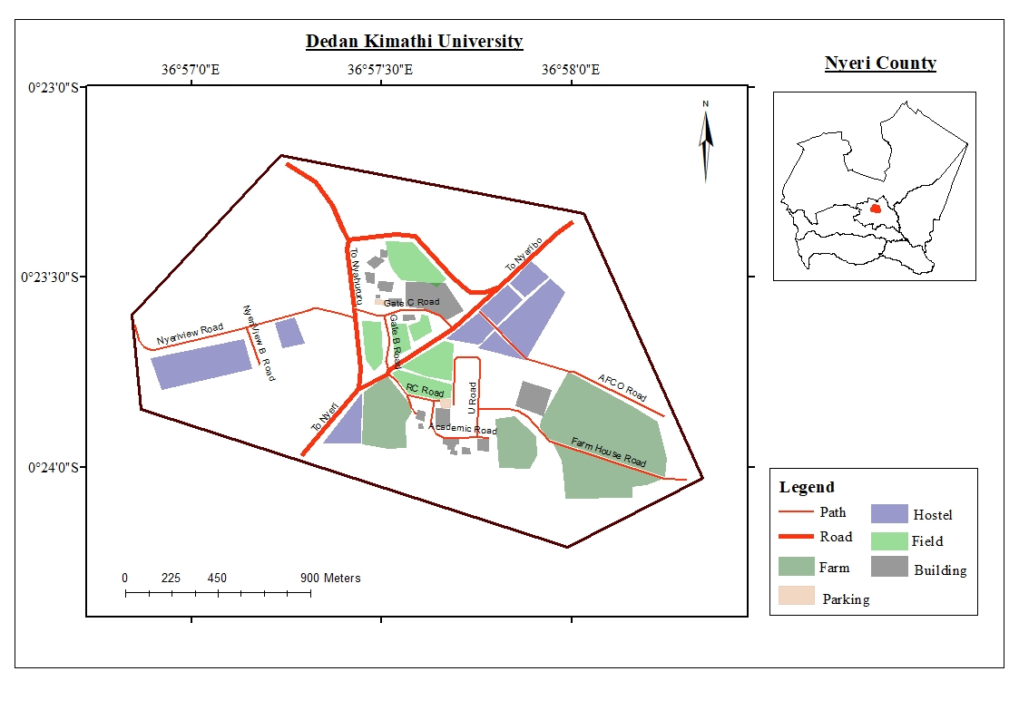
Figure 3.1: Area of study

Research Materials
The target audience for this LBA is the average Kimathi University student. The data shown in Table 3.1 will be crowdsourced with peer-to-peer messaging used as a feedback channel. Table 3.2 shows the specifications of the tools used to develop and test the LBA. This study uses open source software. Table 3.3 shows the software specifications and sources.
Table 3.1: Data Sources
s/n | Data Type | Specifications | Source | Use
1 | Geotagged ad | Ad tagged with (x, y) | User-generated | User intention at (x, y)
2 | P2P messages | Text | User-generated | Feedback

Table 3.2: Tools
s/n | Tool | Specifications | Source | Use
1 | Laptop | Ubuntu 18.04 | Personal | Server configuration
2 | Mobile Devices | Android 4.0+ | User owned | Development & Data collection

Table 3.3: Software
s/n | Software | Version | Source | Use
1 | Android Studio | 182.5314842 | developers.android.com | Building the user interfaces
2 | Flask | 1.0.2 | flask.pocoo.org | Writing the backend APIs
3 | ElasticSearch | 7.0.0 | elastic.co | Provide search
4 | PostgreSQL | 11.2 | postgresql.org | Archiving the data
5 | Heroku | n/a | heroku.com | Hosting the server

Methodology
Figure 3.2 shows the methodology flowchart for this study. The general workflow consists of reviewing the existing LBAs, coming up with a proof of concept for Kimathi University and then evaluating the performance of the LBA by making use of real user data. This will involve:

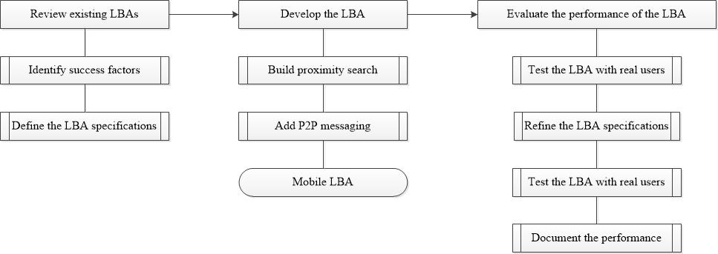
Figure 3.2: Methodology flowchart

- Reviewing existing LBAs
- Identification of success factors
This involves reviewing literature relating to existing LBA systems in other regions. The aim is to identify factors that have contributed to the success and failure of these applications through a comparison between findings obtained by different LBA operators.
- Definition of the LBA’s specifications
This involves relating the success factors to the local context to come up with the initial specifications for the LBA. The product will be the specifications for a minimum viable product.

- Development of the LBA
Figure 3.3 shows how the various components link in the final version of the LBA. The LBA development will be in two phases. The first phase will be to build the advertisement creation functionality and then adding peer to peer messaging. The system overview is as follows:

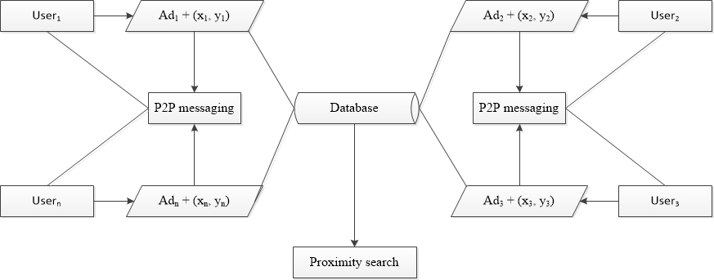
Figure 3.3: System flowchart

- Development of proximity search
The main data input is user-generated geotagged advertisements. These advertisements broadcast user intention at a particular location. Users can search for advertisements for an item of interest. The ranking of results will be by proximity to the user. Proximity will computed using the Haversine formula. This formula computes the Euclidian distance between two points on the earth’s surface using their latitude and longitude. The formula assumes the earth is a perfect sphere. This is a convenient approximation given the simplicity of distance computations in real-time (Arifin & Ibrahim, 2016). Another implicit assumption is the correlation between Euclidian distance and route distance between two points i.e in most instances the the greater the Euclidian distance the greater the route distanceand viceversa.
(3.1)
Where d = distance between two points, r = earth’s radius (6371 km), (ϕ₁, λ₁), (ϕ₂, λ₂) = latitude, longitude for point 1 & 2 respectively in radians
- Development of peer to peer (p2p) messaging
Successful Mobile LBA tends to be more personal compared to other LBS. P2P messaging provides a social touch to the LBA to build user trust. This also acts as a feedback channel between advertisement creators and potential customers. Creators, therefore, have a simple way to gauge traction and interest for what they are selling. Messaging will make use of web sockets to open two-way communication between a potential customer and seller. Flask’s socketIO library provides an easy API to implement this functionality.
- Evaluation of the performance of the LBA
- Testing the LBA with real users
At this stage, real users will interact with the LBA. The aim is to codify user concerns and recommendations and use that as input for the next step.
- Refining of the LBA specifications
Initial user interactions with the LBA will determine which functionality to add and what to get rid of. The aim is to keep user pain points to a minimum to boost the success rate of the application. Simulated user data will complement real user data if need arises.

CHAPTER 4: RESULTS AND DISCUSSIONS

Introduction
This chapter presents the results of the study from the definition of specifications of the LBA, to the development and testing of the LBA with user data.

Results and Discussions
- Definition of the LBA specifications
The aim at this stage of the study was to identify the factors contributing to the success of existing LBA applications and use those factors in defining the specifications for an LBA suited to business around Kimathi University. The main LBA specifications identified are:
- Taking the pull approach given that most users have unstable - not always on - internet connections.
- Crowdsourcing the advertisements to reduce the advertisement creations cost.
- Having an effective feedback channel to help gauge the interest in an advertisement and to facilitate further buyer-seller communication.
- Focusing on users as opposed to products. This approach reduces the intrusive nature of push LBA while building user trust in the service.
- Ranking of the advertisements based on their proximity to the user increasing the likelihood of congruency of the advertisement with user interests at a particular location.
- Development of the LBA
The specifications in the previous stage form the blueprint of the LBA. The screenshots of the fully operational LBA are shown below:

Figure 4.4 shows the advertisement creation page. Here the vendor says what they are selling and then tags the advertisement with the location of the business premises. For sellers without specific premises, the application picks their current location. This mimics posters with the further advantage that the seller can create as many advertisements as they need. The page is simple to use and only allows sellers to create text advertisements. The advertisements are not limited to any product category i.e services and goods.
Test users were able to navigate this page and create advertisements with minimal assistance.
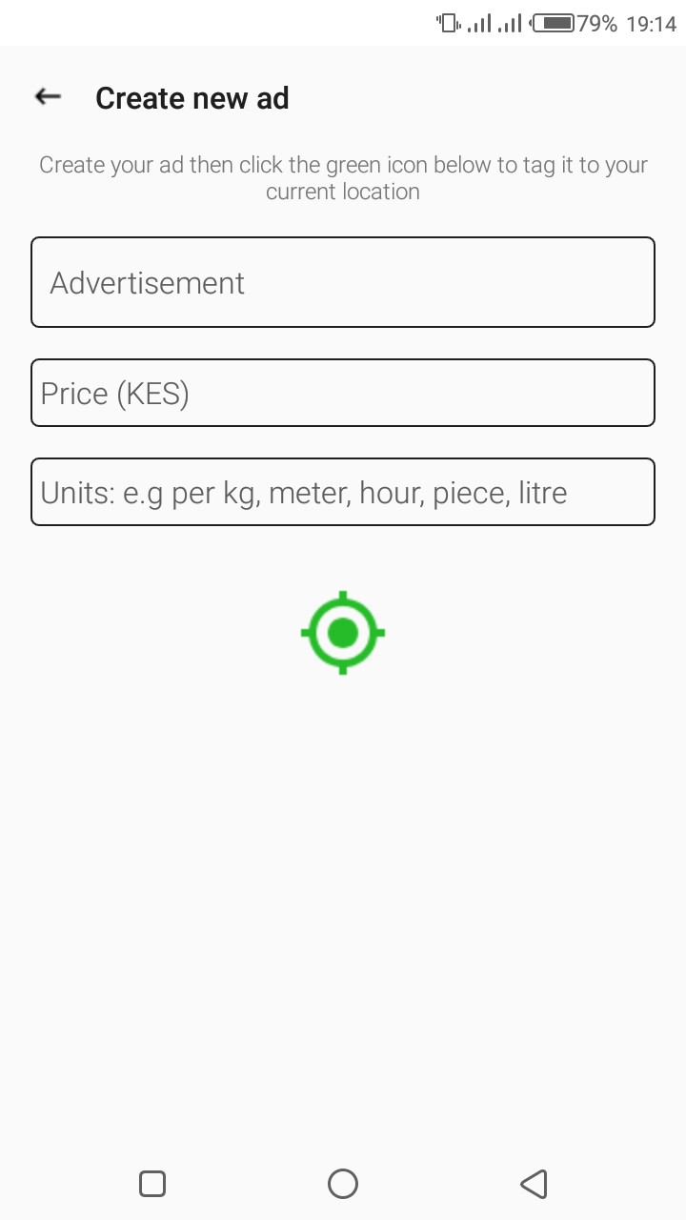
Figure 4.4: Advertisement creation

Figure 4.5 shows the home landing page of the application. The users see the advertisements closest to them first i.e. in ascending order based on distance. This brings about an element of surprise to business discovery while increasing the likelihood of congruency between the advertisements and the user’s current context.
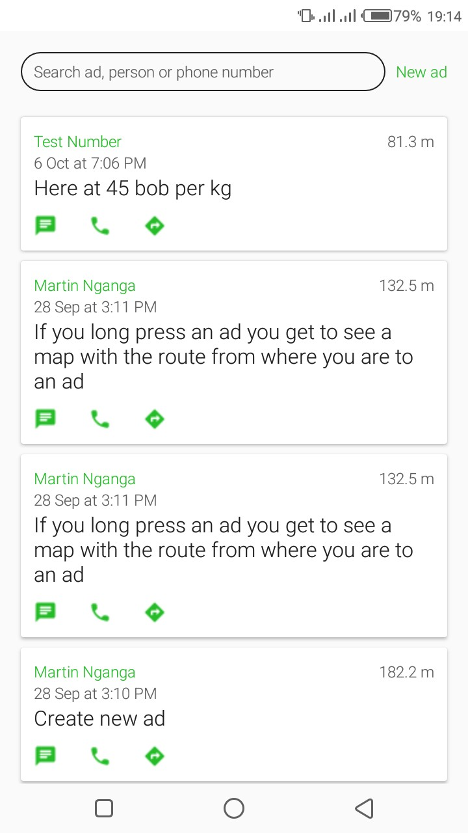
Figure 4.5: Home page

Figure 4.6 shows the search functionality based on the seller’s name (left) and product details (right). Search is meant to actualize the pull LBA i.e. users ‘pull’ the advertisement of interest to them. User see the search results of the advertisements closest to them first.
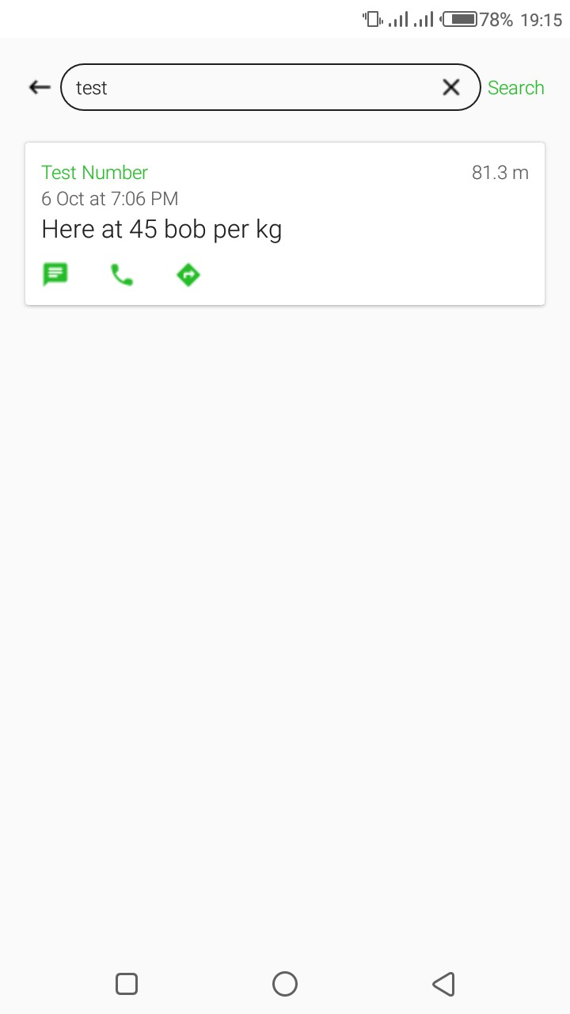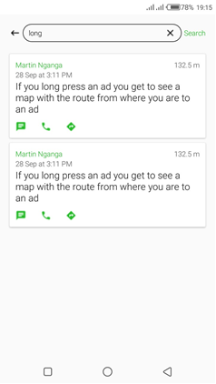
Figure 4.6: Advertisement search

Figure 4.7 shows the mapping functionality of the LBA. This helps the user visualize the route between their current location and the advertisement creation location. A user may prefer a given seller if it is easier to navigate to their business as compared to another seller. The mapping functionality is not core to the application as most users preferred to ask for directions by messaging the seller.
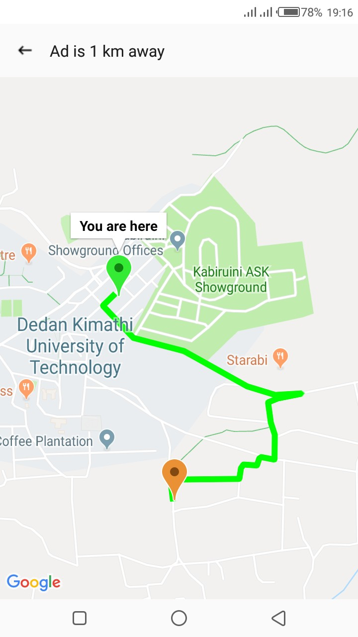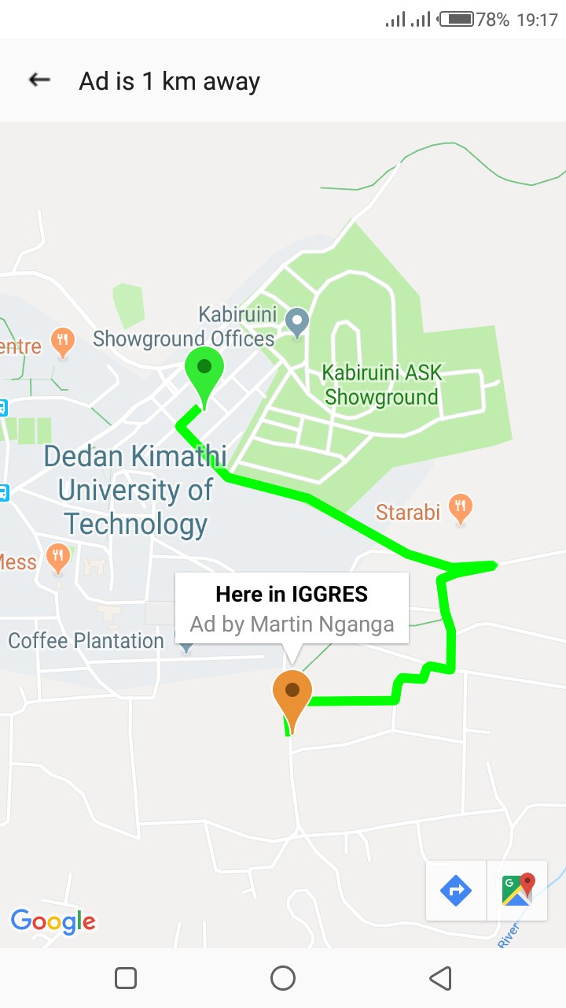
Figure 4.7: Map interface

Figure 4.8 shows peer-to-peer messaging functionality: buyer’s interface (left) and seller interface (right). P2P messaging adds a social aspect to the LBA by helping sellers clarify the product details and allows buyers negotiate a better deal. The messaging is real-time and requires both parties to have an internet connection given that the server only routes the texts without keeping a record of the communication.
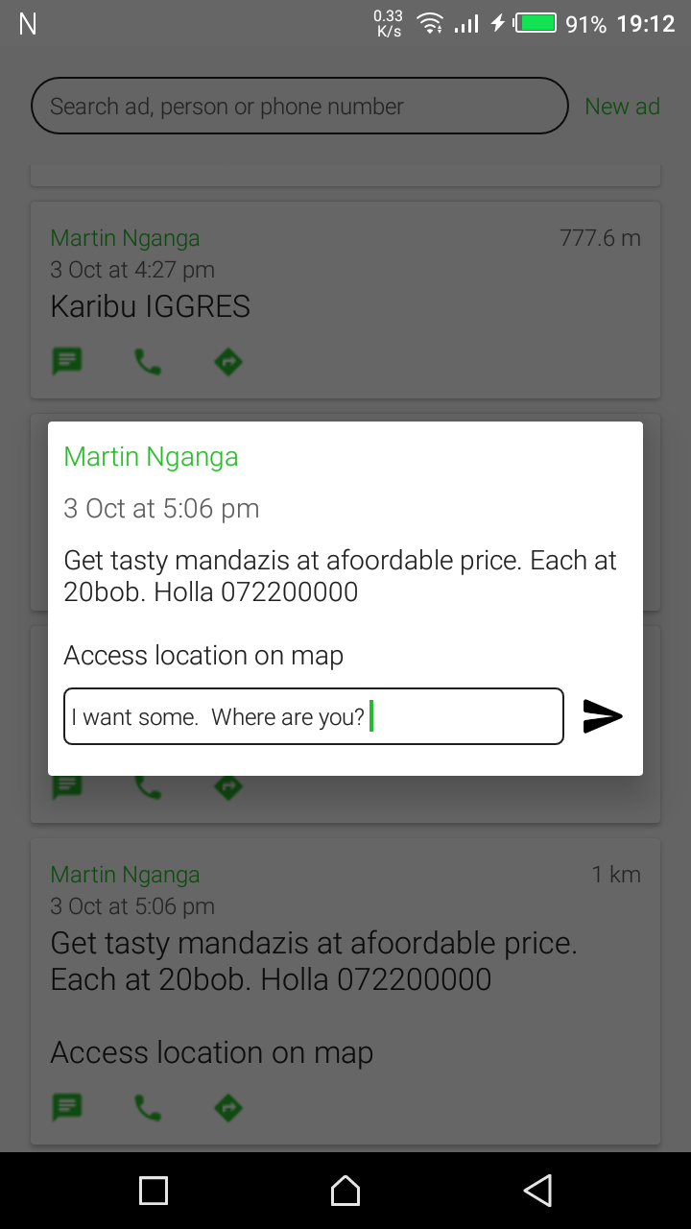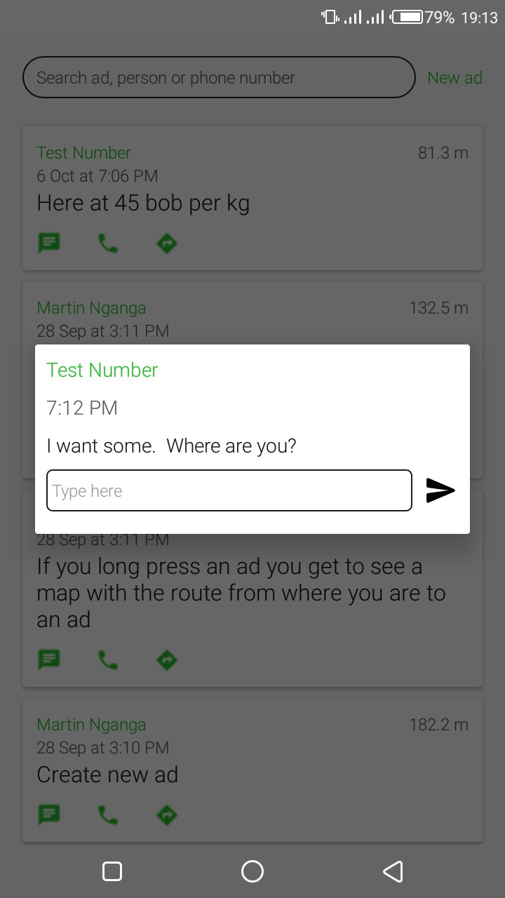
Figure 4.8: Peer to Peer messaging interface

- Performance of the LBA
After developing the LBA, the next stage was testing the LBA with users (students and select vendors). The aim was to determine the validity of the specifications and consequently the utility of the LBA to these users. There were various changes to the initial version based on user feedback to make the LBA more useful. The findings based on user interaction with the LBA are:
- Real-time messaging allows for fast and simple communication between buyers and sellers. However, it falls short as users have unstable internet connections.
- Text advertisements are effective to a certain point and require a lot of messaging for further product details hence the need for multimedia advertisements.
- Indoor positioning is a major issue with some advertisements created indoors having positioning errors as great as 500 meters. The hybrid approach of GPS and network positioning requires at least three minutes to achieve acceptable positional accuracy. A majority of the users perceive three minutes as a huge delay.
- Users are highly sensitive about their location privacy. This is an issue for most user when they create a new advertisement. A common question being ‘How long will this be available?”

Summary of Findings
The overall goal was to simplify advertisement creation process and reduce related costs for small businesses within the Kimathi University region. The current version of the LBA can achieve these objectives to an acceptable degree.
The translation of the LBA specifications to an operational LBA for the local context, however, was not a straightforward process. The success of an LBA is closely tied to the level of digitization of other business processes within the local business ecosystem. The existing LBAs in other areas of the world work with digital inventory management software and delivery services. This allows the LBA to offer delivery services and comparison between offerings by different vendors to offer personalized experiences. This is not the case in our local context given the nature of the businesses themselves (small and personal), the nature of the product offerings (groceries, basic services, etc.) and low levels of digitalization of business processes.

CHAPTER 5: CONCLUSIONS AND RECOMMENDATIONS

Conclusions
The development of the LBA was a success with the LBA proving its utility as a viable advertisement channel for small businesses given its simplicity, affordability and location precision. The majority of test users could easily navigate the LBA to create and search for geotagged advertisements that were specific to a precise location without assistance. The LBA specifications highlighted in this report form a better representation of local requirements and hence a better foundation for local research in LBA. Small businesses will greatly benefit from an operational LBA created specifically for them. Bringing together the various components of this technology and promoting its numerous benefits to a large mass of small vendors presents a major opportunity going forward.

Recommendations
Based on the findings in this study, the recommendations for further research in LBA development are:
- Adding the ability to create multimedia advertisements.
- Refining peer to peer messaging to ensure it works with unstable internet connections.
- Developing better techniques to achieve location privacy and accurate indoor positioning.

REFERENCES
Alt, F., Shirazi, A. S., Schmidt, A., Kramer, U., & Nawaz, Z. (2010). Location-based Crowdsourcing : Extending Crowdsourcing to the Real World. 13–22.
Arifin, Z., & Ibrahim, M. (2016). Nearest tourism site searching using Haversine method. Ieeexplore.Ieee.Org.
Bruner, G. C., & Kumar, A. (2016). Attitude toward Location-based Advertising. Journal of Interactive Advertising, 7(2), 3–15.
Cheng, P., Lian, X., & Chen, L. (2019). Maximizing the Utility in Location-Based Mobile Advertising. Ieeexplore.Ieee.Org.
Developers, A. (2011). What is android.
Fiseha, G. G., & Oyelana, A. A. (2015). An Assessment of the Roles of Small and Medium Enterprises (SMEs) in the Local Economic Development (LED) in South Africa. Journal of Economics, 6(3), 280–290.
Heuer, J. (2007). Towards a spatial search engine using geotags. Gi-Tage.De.
Hosea, M. (2011). How location tools are honing brand radars. Marketing Week, 34(2), 49—52.
Humphreys, L. (2011). Mobile geotagging: Reexamining our interactions with urban space. Academic.Oup.Com.
Jiang, B. (2006). Location-based services and GIS in perspective. 30, 712–725.
Junglas, I., & Watson, R. (2008). Location-based services. Dl.Acm.Org.
Kaplan, A. (2012). If you love something, let it go mobile: Mobile marketing and mobile social media 4x4. Elsevier.
Kazemi, L. (2012). Geocrowd: enabling query answering with spatial crowdsourcing. Dl.Acm.Org.
Kjærgaard, M., & Langdal, J. (2009). Entracked: energy-efficient robust position tracking for mobile devices. Dl.Acm.Org.
Lee, S, & Kim, K. (2015). Customization in location-based advertising: Effects of tailoring source, locational congruity, and product involvement on ad attitudes. Elsevier.
Lee, Sangmee, Kim, K. J., & Sundar, S. S. (2015). Customization in location-based advertising: Effects of tailoring source, locational congruity, and product involvement on ad attitudes. Computers in Human Behavior, 51, 336–343.
Lin, T. T. C., Paragas, F., Goh, D., & Robert, J. (2017). Technological Forecasting & Social Change From my perspective Developing location-based mobile advertising in Singapore : A socio-technical perspective. Technological Forecasting & Social Change, 103(2016), 334–349.
Lokhande, P., Aslam, F., Hawa, N., & Munir, J. (2015). Efficient way of web development using python and flask.
Paavilainen, J. (2012). Mobile business strategies: understanding the technologies and opportunities.
Paragas, F., Goh, D., Lin, T., & Bautista, J. (2016). Developing location-based mobile advertising in Singapore: A socio-technical perspective. Elsevier.
Priambodo, B., Ani, N., & Jumaryad, Y. (2019). Predict Next User Location to Improve Accuracy of Mobile Advertising.
Rahimi, A., & Cohn, T. (2016). pigeo: A python geotagging tool. Aclweb.Org.
Rice, R. E., & Hagen, I. (2010). Young Adults’ Perpetual Contact, Social Connectivity, and Social Control through the Internet and Mobile Phones. Annals of the International Communication Association, 34(1), 3–39.
Ronacher, A. (2018). Flask (a Python microframework). Dosegljivo. Retrieved July 29, 2019, from https://flask.pocoo.org
Schade, M., Piehler, R., Warwitz, C., & Burmann, C. (2018). Increasing consumers’ intention to use location-based advertising. Journal of Product & Brand Management, 27(6), 661–669.
Shin, W., & Lin, T. T. (2016). Computers in Human Behavior Who avoids location-based advertising and why ? Investigating the relationship between user perceptions and advertising avoidance. Computers in Human Behavior, 63, 444–452.
Shoaibi, D. (2012). Mobile advertising using location based services. Ieeexplore.Ieee.Org.
Tsang, M. M., Ho, S.-C., & Liang, T.-P. (2004). Consumer Attitudes Toward Mobile Advertising: An Empirical Study. International Journal of Electronic Commerce, 8(3), 65–78.
Tsou, M. (2018). The Future Development of GISystems, GIScience, and GIServices.
Unni, R., & Harmon, R. (2007). Perceived Effectiveness of Push vs. Pull Mobile Location Based Advertising. Journal of Interactive Advertising, 7(2), 28–40.
Zolfaghar, K., & Khoshalhan, F. (2010). User acceptance of location-based mobile advertising: an empirical study in Iran. Igi-Global.Com.
Zubcsek, P. P., Katona, Z., & Sarvary, M. (2017). Predicting Mobile Advertising Response Using Consumer Colocation Networks. Journal of Marketing, 81(4), 109–126.

APPENDICES

Appendix A: Source Code
This section shows where to find the LBA, the entire source code for the LBA and code samples for the application.
A.1 Download Links
The LBA application is live and can be downloaded at (http://bit.do/gegis-ansa). The complete web and application source code can be found at (https://github.com/ansax/ansa) and (https://github.com/ansax/ansa_android) respectively.
A.2 Web Service
Below is a code sample of the web service:
Creating the advertisement index
@whooshee.register_model('username', 'phone', 'msg')
class Ad(db.Model):
__tablename__ = 'ads'
id = db.Column(db.Integer, primary_key=True)
user_id = db.Column(db.Integer, index=True)
username = db.Column(db.String(20), index=True)
phone = db.Column(db.String(10), index=True)
msg = db.Column(db.String(140), index=True)
latitude = db.Column(db.Float())
longitude = db.Column(db.Float())
created = db.Column(db.DateTime(), default=datetime.utcnow)

Creating a new advertisement
@app.route('/ads/', methods=['POST'])
def new_ad():
ad = Ad.from_json(request.get_json())
db.session.add(ad)
db.session.commit()
whooshee.reindex()
return jsonify(Ad.to_json(ad))

Fetching new advertisements
@app.route('/ads/', methods=['GET'])
def get_ads():
ads = Ad.query.order_by(Ad.created.desc()).limit(10)
return jsonify({'ads': [Ad.to_json(ad) for ad in ads]})

Search
@app.route('/search', methods=['POST'])
def search():
search_terms = request.get_json().get('search_terms')
results = Ad.query.whooshee_search(search_terms, order_by_relevance=10).all()
return jsonify({'search_results': [Ad.to_json(result) for result in results]})

Using websockets to send messages
@socketio.on('send message')
def handle_my_custom_event(json, methods=['GET', 'POST']):
recipient = json.get('to_phone')
json['created'] = time.strftime("%a, %d %b %Y %I:%M:%S %p %Z", time.gmtime())
socketio.emit(recipient, json)
A.3 Android Application
Figure A.1 below shows the app directory structure. The Java classes with the business logic are listed on the right. The naming is based on the user activity that the class controls e.g Home activity controls the home landing page of the app. The res directory below the Java classes contains the user interface components.

Figure A.1: Android app directory structure

